11.17: Consider the forces on Clea.

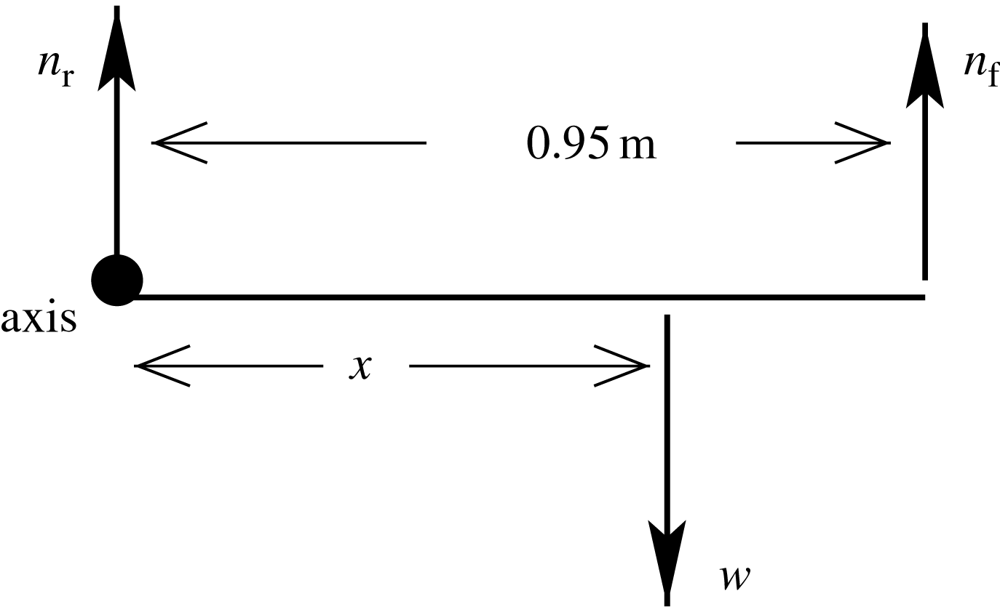

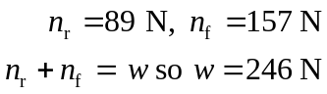

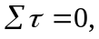 axis at rear feet
Let x be the distance from the rear feet to the center of gravity.
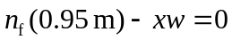
x = 0.606 m from rear feet so 0.34 m from front feet.

